HOW TO PRINT on the school network from a mobile device
*Android phones do not print easily on our network –iPhones will print if you are signed in on the FKSS BYOD network
To print from a personal laptop or a school laptop, you can use the web based EveryonePrint service. Follow the steps below to print your documents.
- Visit http://epc.edu.sd79.bc.ca
- Login with your printing username and password
Supported file types for web printing
Microsoft Office | doc, docx, xls, xlsx, ppt, pptx
Open Office | odt, ods, odp
Adobe | pdf
Images | jpg, gif, png, bmp, tiff
Web pages | htm, html
Text files | txt, rtf csv, log
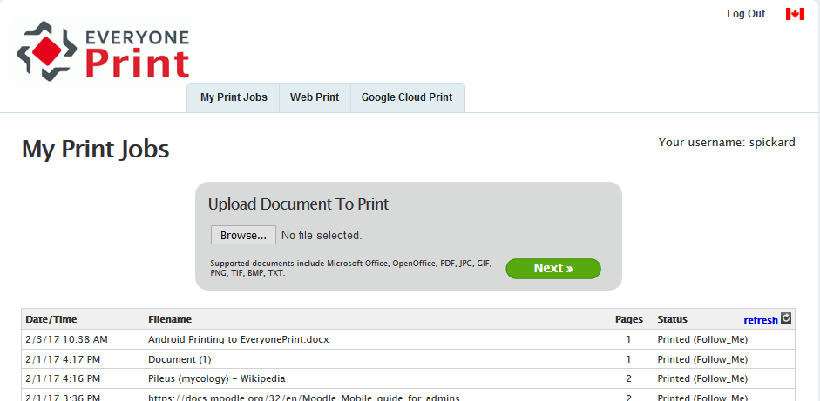
Click Browse to upload your document/image
Click Next to print your document/image

If you have a particular website that you would like to print:

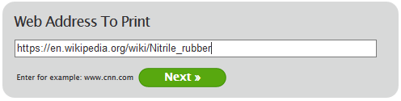
Paste the address of the website that you are printing in here
Click Next to print the web page
Click on the Web Print tab at the top of the window

