**Pre-Calc. 11 LG 16A QUIZ (Formative Assessment)**

**Marking Teacher: _______________________ Name: __________________**

**Student #: __________________**

1. Sketch a graph and state the solution(s) for the following functions.

*f(x)* = (*x* – 2)2 – 3 and *f(x)* = *x* + 2



1. Solve the system of equation. *A* = 2*x* + 3

*A* = *x*2 + 2*x* + 4

1. Which ordered are solutions to the given inequality? **[ circle best answer ]**
   1. *y* > 2*x* +5 ( 0, 0 ), ( -1, -4 ), ( 1, 9 ), ( -5, -5 )
   2. 2*x* + 3*y* < 6 ( 4, 7 ), ( -2, 8 ), ( 7, 2 ), ( 0, 0 )

**4.** Graph the inequality without technology 3*x* + 5*y* > 20



1. Graph the inequality with technology and state the *x*-intercept & *y*-intercept.

-4*x* – 13*y* < 28 *x*-intercept ________ *y*-intercept _________

**6.** Determine the equation for the inequality that corresponds with the graph.

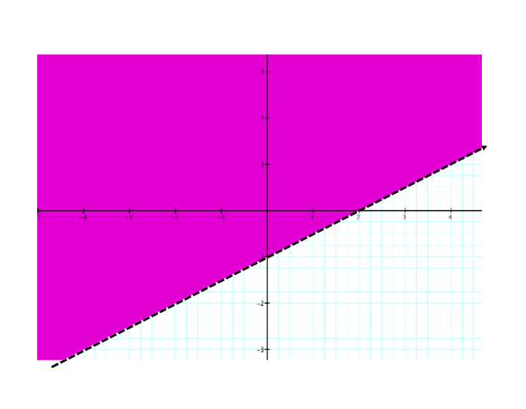

For questions #7 – 10 use the following problem.

Suppose you are going to Disneyland for a day. The most you can spend in one day is $50.   Rides cost on average $4 per ride, and food cost on average $11 per meal.

**7.** Write the inequality that represents the number of rides you can do in that day and the         of meals you can eat in that day keeping within your budget of $50.

**8.** Graph the inequality and state an appropriate window setting for your graph.

Xmin = ______ Ymin = ______

Xmax = ______ Ymax = ______

**9.** List two different ordered pairs in the solution.

**10.** Sketch the graph.



|  |  |  |  |  |  |  |
| --- | --- | --- | --- | --- | --- | --- |
| Directions: |  | **See me about this** |  | **Move on to next guide** |  | **Review and redo** |

**Pre-Calc. 11 LG 16B QUIZ (Formative Assessment)**

**Marking Teacher: _______________________ Name: __________________**

**Student #: __________________**

**1.** Sketch a graph and state the solution(s) for the following functions.

*f(x)* = (*x* + 2)2 + 1 and *f(x)* = *x* – 2



**2.** Solve the system of equation. *y* = *x* + 3

*y* = *x*2 + 2*x* + 3

**3.** Which ordered are solutions to the given inequality? **[ circle best answer ]**

* 1. *y* > 2*x* +5 ( 0, 0 ), ( -1, -4 ), ( 1, 9 ), ( -5, -5 )
  2. 2*x* + 3*y* < 6 ( 4, 7 ), ( -2, 8 ), ( 7, 2 ), ( 0, 0 )

**4.** Graph the inequality without technology 2*x* + 3*y* < 12



**5.** Graph the inequality with technology and state the *x*-intercept & *y*-intercept.

-14*x* – 3*y* < 38 *x*-intercept ________ *y*-intercept _________

**6.** Determine the equation for the inequality that corresponds with the graph.

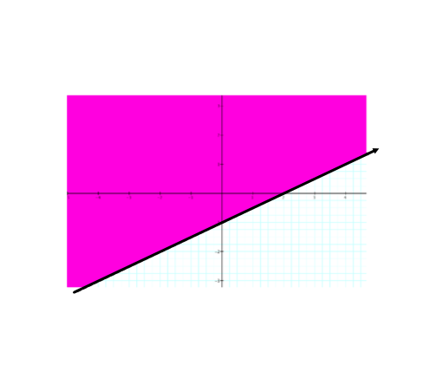

**For questions #7 – 10 use the following problem.**

Suppose you are going to build a shed. The most you can spend is $500.  Wood cost on    average $22 per m2, and roofing cost on average $45 per m2.

**7.** Let x represent the area of wood, and y be the area of roofing. Write an inequality                  equation for this situation keeping within your budget of $500.

**8.** Graph the inequality and state an appropriate window setting for your graph.

Xmin = ______ Ymin = ______

Xmax = ______ Ymax = ______

**9.** List two different ordered pairs in the solution.

**10.** Sketch the graph.



|  |  |  |  |  |  |  |
| --- | --- | --- | --- | --- | --- | --- |
| Directions: |  | **See me about this** |  | **Move on to next guide** |  | **Review and redo** |