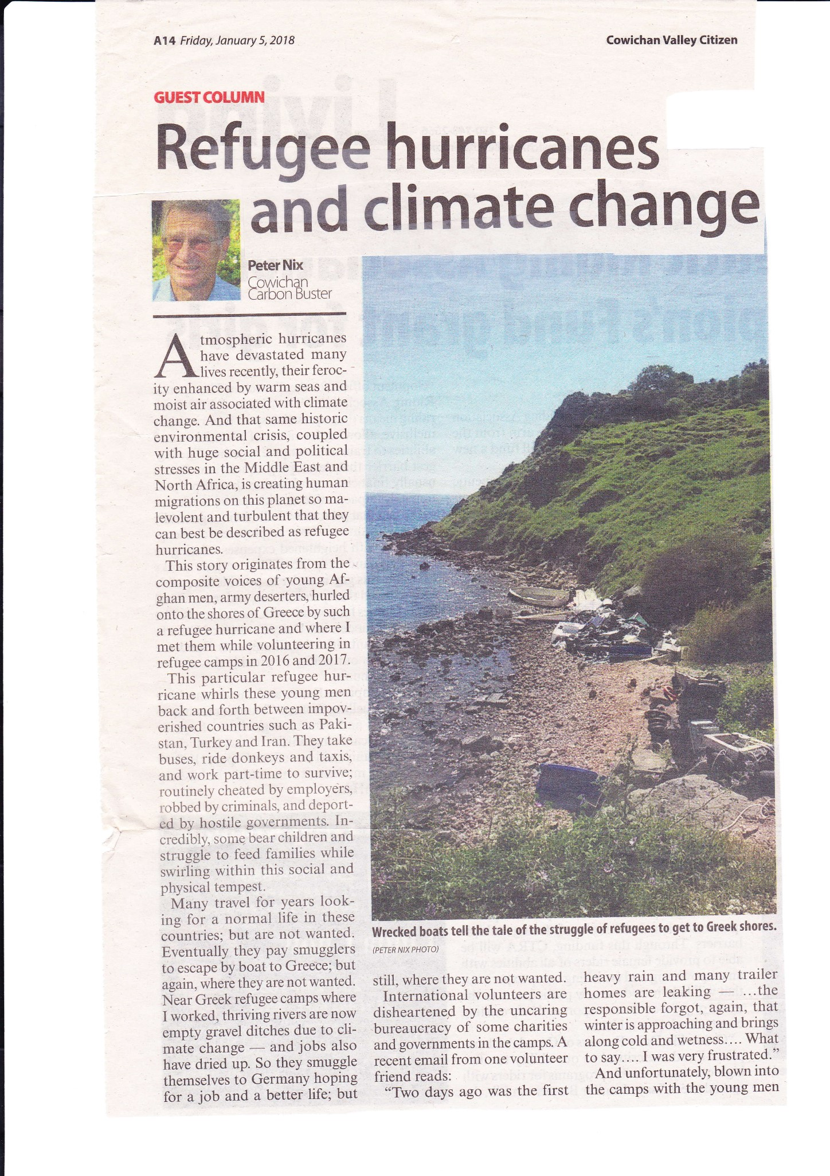
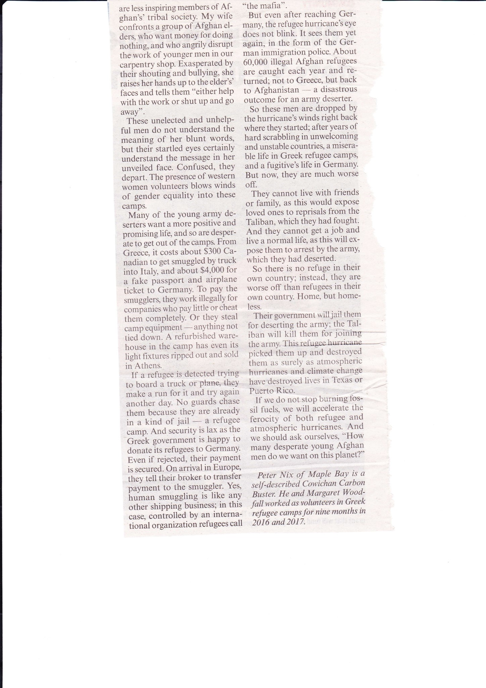

Solving Big Social Problems by Thinking Small
Frugal, flexible, and inclusive “jugaad innovation” provides a compelling model for nonprofits looking for innovative solutions to significant problems.
By Jaideep Prabhu Apr. 21, 2017
I've spent my career studying innovation. What has struck me over the years is how differently large Western corporations and innovators in emerging markets like India, where I grew up, approach it.
“Jugaad” is the Hindi word for finding low-cost solutions in an intelligent way, and “jugaad innovation” is a term to describe three common traits of Indian entrepreneurs. First, Indian entrepreneurs are very frugal in their approach, very good at doing more with the limited resources they have. Second, their mindset is very flexible. There is a lot of improvisation and lateral—creative, nonlinear—thinking. And third, their solutions seem designed to bring people who are outside the formal economy into the formal economy, so these solutions are very inclusive.

A lesson in a fridge
Let me illustrate with a comparison of refrigerator technology. In advanced countries, consumers can spend as much as $3,000 for a fridge intelligent enough to talk to them. But for a fraction of that price in India, thanks to a humble social entrepreneur, the poor can buy a $30 clay fridge that uses the cooling properties of water stored in a reservoir at the top. When that water evaporates through the clay, it keeps fruit and vegetables fresh for up to five days—without electricity.
The message to Western corporations—and a lesson from which nonprofits also can learn—is that they can no longer just rely on the old formula of top-down strategies, expensive R&D projects, and highly structured innovation processes. Rather, they should consider jugaad’s bottom-up approach to frugal and flexible innovation.
My coauthors Navi Radjou, Simone Ahuja, and I defined “jugaad innovation” as the art of improvising “good-enough” solutions using limited resources. And interestingly, when we published our book on the topic in 2012, people from other parts of the world, such as Brazil, wrote to say, "We have something similar in our country." Moreover, we’re now seeing equivalents in the West. A good example is the Raspberry Pi, a $30 computer originally designed to help schoolkids in the United Kingdom—and now around the world—tinker with computer hardware and learn coding.

Innovation inspired by adversity
The story of the clay fridge reveals some underlying principles of jugaad. Its inventor, Mansukhbhai Prajapati, has a high school education and grew up in a family of potters. In 2001, an earthquake devastated his village in the Indian state of Gujarat. On a morning soon afterward, he opened the local newspaper to see a picture of a broken clay pot under the caption: "Poor man's fridge broken." And that actually gave him the inspiration. He set up a factory and trained local women to make clay refrigerators. What had been a disaster ended up providing women with additional income, and he went on to sell these to other poor people via the Internet. Prajapati’s work embodies the six principles of jugaad:
- Doing more with less—and of course that's what these people do beautifully. They take the resources they have in plenty and use them to substitute for resources they don't have.
- Creating very simple solutions. The design helps to conserve resources, but a simple design also ensures that these innovations will be widely adopted and easily maintained.
- Using an agile approach. A traditional approach might suggest “How do we create a refrigerator cheap enough for poor people to buy, and provide affordable electricity to operate it?” Lateral thinking says “How do we take materials readily available at an affordable cost and turn them into reliable refrigeration?”
- Getting inspiration from adversity (the earthquake, in this case).
- Viewing marginal people as not only beneficiaries, but also part of the solution.
- Following passion. These innovators really follow their hearts. This is important, because what they're doing is quite difficult and requires persistence.
Large NGOs face the challenge that innovation can be expensive and slow; it’s hard to be agile because of legacy processes and because it’s hard to include outsiders.
One example of how to overcome the “must-be-invented-here syndrome” is to find more agile outside partners and co-develop solutions. This has been demonstrated by Ford Motor Company, which empowered its product-development employees to tinker with innovation tools and software at TechShop Detroit, an independent research lab. The collaboration has succeeded in reducing Ford’s R&D costs, motivating its employees, and increasing the number of patents it has filed.
Barclay’s Bank, meanwhile, has begun partnering with financial technology startups to develop customer solutions by mining data the bank is unable or unwilling to exploit on its own. The bank even has accelerators in four countries that house and then absorb innovations from the startups as they mature.
Among NGOs, perhaps the most impressive example I’ve encountered is Bangladesh’s BRAC, which does frugal innovation at scale in areas such as primary health and primary education. It also sponsors an annual Frugal Innovation Forum.
Jugaad also informs some of the most creative multinational initiatives in financial inclusion, drawing in people outside the formal economy. M-PESA, a well-known mobile payment service for typically migrant people not served by a bank, is a good example. With M-PESA, for example, a woman in a rural village can use her basic cellphone to not only speak to her son in Nairobi, but also receive money from him. She could text the request, accept the electronic money on her cellphone, and cash it at a local shop. Today, more than 25 million people use M-PESA in Kenya alone, and many others in countries such as Afghanistan have joined the program.
Meanwhile, researchers at UC Berkeley have created CellScope, which turns cellphone cameras into otoscopes and dermascopes—devices that let parents monitor their children’s symptoms at home and send the list of symptoms to consultants who are located remotely.
As we attempt to solve important questions at scale, this kind of frugal, flexible, inclusive innovation is just what the world needs. Organizations don’t need to actually be big to think big in ways that improve lives everywhere.

Jaideep Prabhu is the Jawaharlal Nehru Professor of Business and Enterprise at the Judge Business School at the University of Cambridge, England. This opinion is adapted from a talk (which you can listen to here) at The Bridgespan Group-Harvard Business School 2017 Summit on Transformative Impact.

Cultural Identity a Challenge for Children of Immigrants

By Tara Sprickerhoff
OTTAWA — Faiza Mehboob’s life is full of contradictions. She’s part of a sorority, yet abstains from alcohol. She lives in an apartment by herself, yet lets her sister know she is home every night.
Mehboob is one of a number of youth in Canada who straddle two cultures, living at home in one culture, while working and attending school in a completely different cultural context.
She is what academics call a “second-generation Canadian,” meaning that while she was born in Canada, her parents immigrated here.
“I feel like I am living a double life. I’m a certain person here, and when I go home I conform to a different person there. I don’t do it intentionally.”
– Faiza Mehboob
The Canadian Council on Social Development suggests that foreign-born youth and second-generation youth will make up a quarter of the Canadian youth population by 2016, while Statistics Canada predicts that nearly half of Canadians above the age of 15 will have at least one immigrant parent by 2031. Who are these Canadians? And what are the challenges they face?
“Youth of all cultures face challenges,” says York psychology professor Richard Lalonde who studies the social identity of second-generation Canadians. He says that second-generation youth, particularly those with parents from eastern backgrounds, can experience conflict in reconciling the Euro-Canadian culture they experience at school with the one they experience at home.
Mehboob is no stranger to this sense of conflict.
“I feel like I am living a double life,” she says. “I’m a certain person here, and when I go home I conform to a different person there. I don’t do it intentionally.”
A lot of it, she says, comes down to the amount of freedom she has attending school at Carleton University in Ottawa, while her Pakistani-Canadian family lives in Toronto.
At home, she is required to be home before sunset, when the daily Muslim Maghrib prayer takes place, she dresses even more modestly, and is “constantly asking for permission to go places.”
Some of this follows her to Ottawa, where her sister calls to make sure she is home every night.
Still, Mehboob does adhere to many parts of her parents’ culture and religion. She refrains from using alcohol and drugs, eats only Halal meat, and has never had a boyfriend.
“It sucks because I don’t want to be living two separate lives. If I could have one and have it be accepted by both cultures it would be great.”
Mehboob, right, wears a traditional Pakistani dress, next to one of her sorority sisters.
This conflict of values puts some second-generation Canadians in a “bind,” says Lalonde.
“On the one hand, they’ve adopted, or are at least knowledgeable about, the mainstream norms they’ve been developing in Canadian society for a while. On the other hand they are mindful of the norms of their family and their cultural heritage,” he says. “It’s like ‘What should I do? Should I follow what my Canadian way of thinking directs me to do, or should I follow the way my heritage directs me?’”
Mehboob, however, is the first to say that she loves her family, and that without them being open to different experiences, she wouldn’t be alone at university in the first place.
For her though, the second-generation “dilemma” comes to a head over the topic of marriage.
“Parents want cultural continuity,” says Monica Boyd, the Canada Research Chair in Immigration, Inequality and Public Policy at the University of Toronto. This can result in tension between parents and youth.
Mehboob says her father is “adamant” about arranged marriage, but Mehboob and her older, already married, siblings have all pushed successfully to choose their own partners. Still, there is the pressure to be married, she says.
While Mehboob says she wants to find a partner who shares not only her Muslim and Pakistani background and also has the same religious and cultural values, she is also looking for someone in tune with western culture.
It’s proving more difficult that she thought it might be.
Mehboob also worries about her children losing her cultural heritage.
“I hope I’m a tool and a resource for religion and for culture for my kids, but at the same time I feel like I might be a better tool for western culture for my kids than for a Pakistani cultural representation,” she says.
Regardless, Mehboob wants to find a way of balancing the two cultures in her life, a “happy medium,” as she calls it.
“Our parents don’t understand that we need to live our life and that we’re not living in the same country, living in the same culture, living in the same social society as they grew up in,” Mehboob says.
“The values that we have, yes they are religiously and culturally tied to us but we also have another value set that we need to take into account too. You don’t just come to Canada and then keep acting like you are in Pakistan. That’s not how it works.”

What to Know About March for Our Lives and Other Student-Led Gun Control Protests
By SARAH GRAY
Updated: March 12, 2018 12:10 PM ET | Originally published: February 20, 2018
The shooting at Marjory Stoneman Douglas High School in Parkland, Florida on Feb. 14 left 17 students and staff dead — and replaced the 1999 Columbine High School massacre as the deadliest high school shooting in America. Many of the survivors, thousands of teenagers who used social media to document the horror, aren’t waiting for the adults to make changes to prevent the next school shooting.
They’re taking matters into their own hands, advocating for stricter gun-control laws and more mental health resources for treating troubled peers. Following the shooting, Marjory Stoneman Douglas students, including Emma Gonzalez, have been vocal on social media and in traditional media to call for action with their refrain “never again.”
Calls to action — from national walkouts on March 14 to a March 24 march on Washington, D.C. — spread on social media.
Here’s a guide to the upcoming events that have been organized by the Parkland shooting survivors:
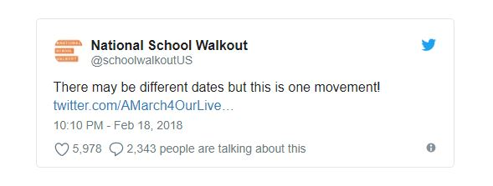

March 1, 2018: Company Boycott
Last week the students from Parkland, Florida began encouraging companies who partner with the NRA — offering perks or discounts to members — to sever ties with the organization. Over a dozen companies have dropped their NRA partnership.
On March 1, actresses Alyssa Milano and Debra Messing along with director Justine Bateman, and Shannon Coulter the co-founder of #GrabYourWallet are planning a full-day boycott of three specific companies that have ties to the NRA. They’re boycotting Amazon and Apple (their respective products Amazon Fire and Apple TV stream NRA TV) and FedEx, which offers a discount to NRA members.
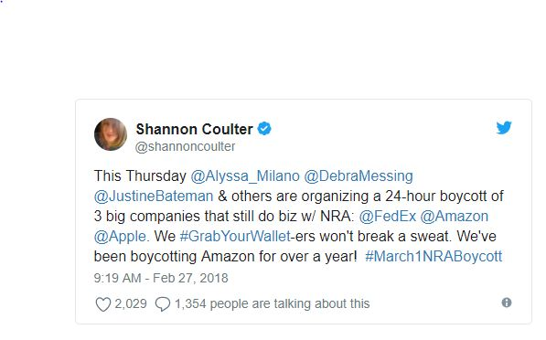

FedEx has come under fire on social media for offering a discount to NRA members. The company released a statement earlier this week saying that “FedEx Corporation’s positions on the issues of gun policy and safety differ from those of the National Rifle Association (NRA). FedEx opposes assault rifles being in the hands of civilians.”
Apple and Amazon haven’t commented on the issue and didn’t immediately respond to requests for comment. NRA TV is also available on Roku, and Google’s Chromecast, according to the NRA’s website.

March 14, 2018: National School Walkout
The Women’s March’s Youth EMPOWER group is planning a national school walkout on March 14, 2018, according to the group’s website. At 10 a.m. in every time zone, organizers are encouraging teachers, students, administrators, parents and allies to walk out for 17 minutes — one for every person killed at Marjory Stoneman Douglas High School.
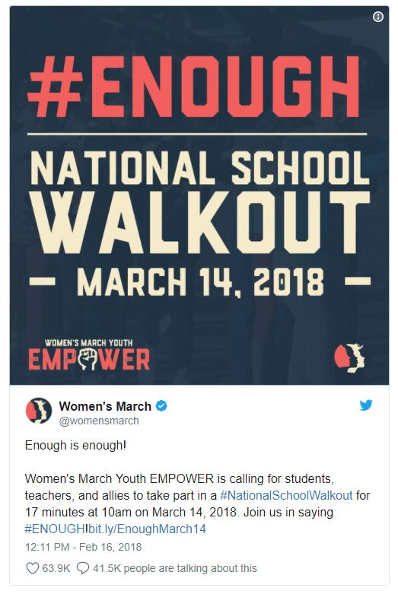
Twitter Ads info and privacy
“Students and staff have the right to teach and learn in an environment free from the worry of being gunned down in their classrooms or on their way home from school,” according to the site.

March 24, 2018: March For Our Lives:
Students from Parkland — along with support from national organizations like Everytown for Gun Safety; Giffords, the gun safety group founded by wounded former Congresswoman Gabby Giffords; Planned Parenthood and others — are planning March For Our Lives, on March 24, 2018, a march in Washington, D.C., to call for school safety and gun control.
“The mission and focus of March For Our Lives is to demand that a comprehensive and effective bill be immediately brought before Congress to address these gun issues,” according to their website. “No special interest group, no political agenda is more critical than timely passage of legislation to effectively address the gun violence issues that are rampant in our country.”
The D.C. march is starting at 10 a.m., according to the March For Our Lives Facebook page. Sister marches have also popped up around the globe and in other major U.S. cities including New York City, Chicago, San Francisco and Boston. Information on other rallies is available on the March For Our Lives website.
According to a tweet from March For Our Lives, the ride share company Lyft is offering free rides to marches across the country on March 24.
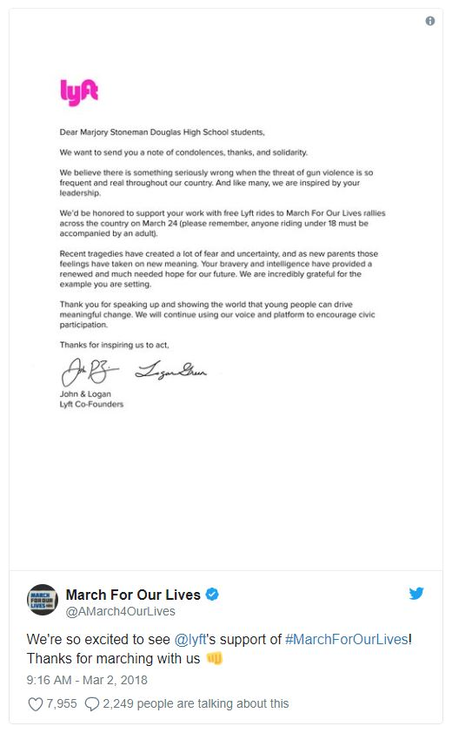
Twitter Ads info and privacy
TIME reached out to Lyft to see if there’s any other information about the rides and will update as necessary.
The March For Our Lives organizers also launched Vote For Our Lives to encourage people to register to vote.

April 20, 2018: National High School Walkout:
A growing movement titled #NationalSchoolWalkout is being called for by Connecticut student Lane Murdock and others. Murdock lives just 20 minutes away from Sandy Hook Elementary School, according to NBC News. In December 2012, 20 students and six staff members were gunned down at Sandy Hook.
The plan calls for high school students to walk out on April 20, the 19th anniversary of the Columbine shooting, from at 10:00 a.m. local time until the end of the school day. The walkout encourages students to stay on campus in a common space for 17 minutes of silence in honor of the 17 people killed at Marjory Stoneman Douglas High School, and then to participate in an open mic.
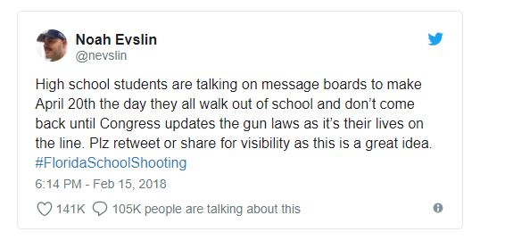
More information is available on their website including resources for students planning marches at their schools.

Ongoing calls to action.
A letter writing campaign started by Parkland students, named #NeverAgain: Pick Up A Pen, has also been circulating on Twitter.
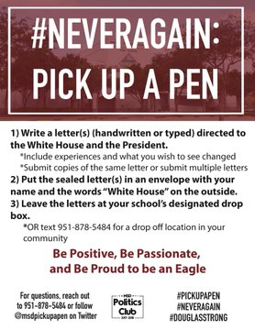
Twitter Ads info and privacy
Actor Josh Gad has also started a challenge to raise money for a scholarship in honor of Alex Schachter one of the students killed at Marjory Stoneman Douglass. Schachter’s poem “Life Is Like A Roller Coaster” was read by his father at CNN’s Town Hall last week.
Gad is asking people read the poem, donate $15 and challenge more people to continue reading and sharing.
Twitter Ads info and privacy
And the students of Marjory Stoneman Douglas are also recording videos and encouraging other students to do the same with the hashtag #WHATIF to encourage politicians to act on gun control and student safety:
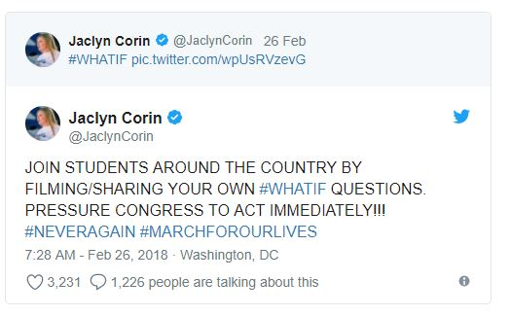

Design Challenge 2 Article (2018)
Design Challenge 3 Article (2018)
Design Challenge 4 Article (2018)

